THE SECRET COACH:
FOOTBALL LEGEND HARRY REDKNAPP RETURNS TO PORTSMOUTH, SURPRISING KIDS AT SUMMER FOOTBALL CAMP
- To celebrate Kellogg’s’ new summer football programme for kids aged 5-15yrs*, the sports legend returned to his former club to host a surprise tips and tricks session.
- Kellogg’s is offering 30,000 free spaces for football camps in the first summer of launching, with thousands still available to book.
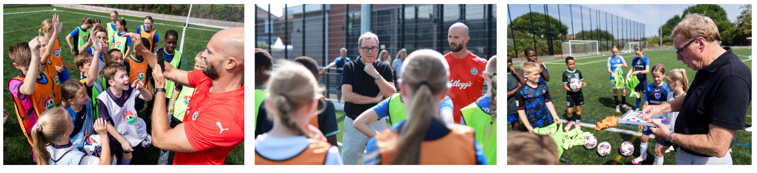
- Parents will need to move fast to grab the last available spots with redemptions closing on 12th August.

It’s not often that a national football legend comes to coach your kid’s local summer camp – but that’s exactly what happened for one lucky group of kids when Harry Redknapp surprised them at a football session in Portsmouth.
Ex-Pompey manager, and former King of the Jungle, Harry delighted young footballers by dropping in at Portsmouth’s training ground, the John Jenkins Stadium, yesterday, giving them the chance to follow in the footsteps of their heroes and offering advice on how they can improve their skills on the pitch.
Harry also delighted kids with tales of his long career, including his FA Cup victory with Portsmouth in 2008 and leading the south coast club to the Premier League in the 2002/03 season. He was joined by football influencer Daniel Cutting (who boasts more than 2.5m social followers across YouTube & Instagram), who entertained kids with various tricks.
As part of Kellogg’s’ first foray onto the football pitch, the new UK-wide footballing camps are coached by FA-approved coaches for 5-15year olds, with more than 70 locations across the country in partnership with the EFL (English Football League), Manchester City, Celtic and Rangers.
Harry Redknapp said: “I hugely enjoyed my time at Portsmouth so it’s great to be back on the pitch here, albeit in a bit of a different setting!
“Football is such a great way for kids to stay active and obviously I am biased, but I really do believe that team sport is an amazing way to help kids develop important skills from building confidence to seeing the benefits of teamwork in action, but also just having fun with other local kids.”
“I have coached many teams throughout the years and football clubs have also been a key part of the community so it makes sense that Kellogg’s would look to further support these institutions, offering children across the UK across the chance to stay active throughout the summer break”.
Although the summer is now in full swing, parents can still sign up for their local camp at the Kellogg’s website (www.kelloggsfc.com)**. 30,000 free spaces are being offered throughout the summer.
Recent research commissioned by Kellogg’s highlighted that more than 8 in 10 parents (86%) want their child to experience less screen time during the break, with the camps offering the ideal way for parents to entertain with fun and activity filled days in the heart of the local community.***
ENDS
Imagery available to download here.
For all PR enquiries, contact kelloggs@wcommunications.co.uk.
*Exact age ranges differ from each club as outlined on kelloggsfc.com
*18+, GB only. 500 camp places available between 01/08/24 – 30/08/24. Use code 4567 instead of last four digits from a pack barcode and kelloggsfc.com to claim camp day. Max 2 claims per household. See website for full T&Cs, further prize details, camp locations, availability of camp spaces & exempt clubs. Read all T&Cs here.
For further T&Cs, visit www.kelloggsfc.com. Detail on accessibility to the EFL-led camps: https://www.efltrust.com/3d-flip-book/22126/.
*** Research conducted early February 2024 by 72Point. 2,000 gen pop (parents of 7-11yr olds in England, Scotland and Wales)

