Cornelius the Cockerel Returns! Kellogg’s Ambitious Pan-European Campaign Brings Swagger Back to Breakfast

- Kellogg’s launches new Masterbrand visual identity
- Cornelius the Cockerel returns with an epic reimagining
- The campaign runs across Europe, aiming to reach 150 million people in 2025

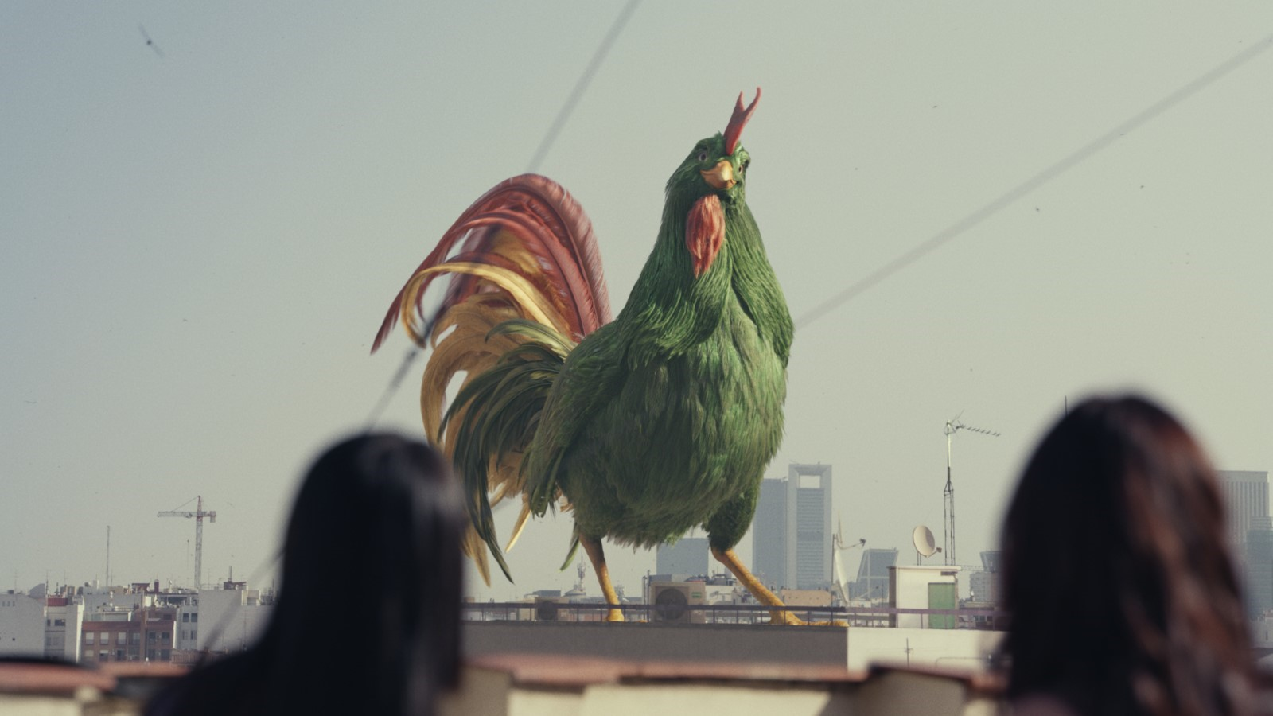

Images: https://www.flickr.com/gp/taylorherringpr/re4T7bx0Fg
Video: https://youtu.be/9TraQjzLcSE

16th December 2024, London UK – Kellogg’s has revealed a bold new visual identity for its cereal portfolio, to build on its legacy of 117 years at the breakfast table and to spur a new growth era for its iconic cereal brands.

Cornelius the cockerel, Kellogg’s beloved mascot since 1958, has been reimagined in a new integrated marketing campaign, See You in the Morning, developed in partnership with Leo Burnett, which celebrates Kellogg’s legacy of being the ‘OG of breakfast’. The new 3D Cornelius will now feature across more of Kellogg’s iconic cereals as part of a 360° full-funnel campaign for the Masterbrand. It will be supported by a £12m investment in the UK across TV, digital, social, OOH, retail and instore.

The integrated campaign debuts in the UK online with a 60 second film on 16th December and on TV from 23rd December, rolling out across the UK in January 2025 and across Europe from February 2025.

The heart of See You in the Morning is the all-new Cornelius the Cockerel, who has never before been brought to life as a fully developed character. Brimming with personality, 3D Cornelius has been concepted and developed with cutting-edge animation by Framestore – the multi–Academy Award-winning studio behind major global hits like Paddington and Harry Potter.

The film opens with Cornelius strutting confidently through the city streets, with effortless swagger, catching the attention of passersby. The vibrant scene is set to iconic hip hop soundtrack – Jurassic 5’s Jayou – marking the first time the track has ever been used in an advertising spot.

As Cornelius moves through the city, realistic morning routines unfold, from a family enjoying breakfast together to a jogger on a morning run. Cornelius blends seamlessly into these moments, catching the attention of children and adults with his commanding figure. The ad builds to a grand crescendo as he leaps onto a rooftop, crowing his iconic call to underscore the campaign’s message: See You in the Morning,celebrating the individuality of mornings with Kellogg’s as a constant presence.

See You in the Morning, was shaped by Kellogg’s largest ethnographic study across Europe, including the UK, conducted by Leo Burnett and Kindling. The research uncovered the truth about mornings, that everyone needs ‘you do you’ time when they wake up and if they don’t get that, they start their day compromised. That insight linked to the fact that Kellogg’s, as the OG, has been waking up the world since 1906, so it simply ‘gets’ mornings and understands that everyone needs to do mornings to suit them.

The launch of social films from January, focussing on You Do You moments, will see Cornelius appear in various morning scenarios, engaging with different breakfast routines from kids rushing to school, to couples sharing quiet moments. The social-first approach invites people to share their own personal morning rituals, further driving engagement and creating a community around the brand.

Set to reach 150 million people across Europe through TV, digital, social and OOH, media planning was planned and managed by Carat. The creative brand platform, See You in the Morning, was created by Leo Burnett. Public Relations is being looked after by Taylor Herring.

The campaign will tap into evolving viewing habits through a progressive AV approach and ensure messaging is highly relevant to consumers through advanced use of data and targeting. A high-impact wave of OOH advertising will also appear on billboards across Europe. The creative features Cornelius alongside the message, “The OG,” in Kellogg’s distinctive typography.

In retail, commerce activations across Europe, developed by LeSHOP, will bring Cornelius and the new brand world to life, establishing Kellogg’s as the original and the best breakfast cereal for everyone’s morning routine, and encouraging shoppers to interact with the brand while purchasing.

See You in the Morning is the beginning of a bold move from Kellogg’s, in which its portfolio of cereal brands, which include Cornflakes, Coco Pops, and Rice Krispies will be advertised under the Masterbrand and newly-created visual identity. The Masterbrand strategy, led by world-leading brand consultants Landor, has been designed to recapture Kellogg’s category leadership, reclaiming its crown position on the shelf and in minds.
Jenn Carkner, VP, Kellogg’s Cereal, said: "Breakfast is deeply personal, and with See You in the Morning,we’re celebrating the unique ways everyone approaches mornings. This campaign brings Kellogg’s iconic status to life in bold and modern ways, ensuring we remain a trusted and loved part of the breakfast table.”
Mark Elwood, CCO, Leo Burnett, added: “‘See You in the Morning’ is our new platform for an iconic brand. We wanted to celebrate Kellogg’s legacy by bringing back Cornelius, the mascot, with all his original swagger, while giving him a fresh energy to connect with a new generation. Mornings feel different for everyone, but starting your day with a bowl of the original classic is always a great choice."

ENDS

#Kelloggs
TikTok | YouTube | Instagram | Facebook

Credits

AD AGENCY: Leo Burnett
CAMPAIGN TITLE: See You In The Morning
CLIENT: Kellanova
ADVERTISING AGENCY: Leo Burnett
CCO: Mark Elwood
CREATIVE DIRECTOR: Marcus Aitman
SENIOR CREATIVE: Joe Miller
DESIGN LEAD: Miriam Menendez
MOTION DESIGN LEAD: Carmen Perez Jimenez
DESIGNER: Karolina Alvekrans
DIRECTOR OF SOCIAL AND COMMS PLANNING: Jen Leung
PLANNING PARTNER: Amelia Redding
SENIOR PLANNER: Roxy Windisch
MANAGING PARTNER: Charlotte Coughlan
SENIOR ACCOUNT DIRECTOR: Tegwen Tucker
ACCOUNT MANAGER: Bryan Osango
ACCOUNT EXECUTIVE: Sonia Kodasse
PROJECT DIRECTOR: Laura Wilkin
AGENCY PRODUCER: Sam Smith
AGENCY PRODUCER: Lou Pegg

PRODUCTION COMPANY: MJZ
DIRECTOR: Matthijs van Heijningen Jr.
PRODUCER: Donald Taylor
PRODUCTION MANAGER: Spike Elwood

EDIT HOUSE: WhiteHouse
EDITOR: Russel Icke
EDIT ASSISTANT: Thomas Sheriff
SOUND: Steve Perski @ Harbor

VFX HOUSE: Framestore
EXECUTIVE CREATIVE DIRECTOR: William Bartlett
2D SUPERVISOR: Jonni Isaacs
CG SUPERVISOR: Joel Savage
ANIMATION SUPERVISOR: Rocky Vanoost

EXECUTIVE PRODUCER: Alexia Paterson
LINE PRODUCER: Robyn Borrageiro
PRODUCTION COORDINATOR: Rachel Knight
PRODUCTION ASSISTANT: Jamie Scott

COMPANY 3
COLOURIST: Jean-Clément Soret
SUPPORTING COLOURIST: Matthieu Toullet
EXECUTIVE PRODUCER: Ellora Soret
ASSISTANTS: Santino Napolitano, Karl Pasamonte, Jack Kennedy

EDITORIAL
FLAME ARTIST: Aadel Matoorianpour
HEAD OF EDITORIAL: Humberto Reynaga
VFX EDITOR: Andrew Fineberg

VFX SHOOT SUPERVISORS: Enrik Pavdeja, Joel Savage

CHARACTER ASSET TEAM
CONCEPT ARTIST: Sam Rowan
ASSET GENERALIST: Bruno Reis Coimbra
ASSET GENERALIST: Billy Butler
HEAD OF GROOM: Gabriela Ruch Salmeron
GROOM TD: Clara Simoné
RIGGING TD: Nathan Clark

ASSET TEAM: Khaled Sabry, Florian Rigollet

ANIMATION TEAM: Adam Bailey, Alfonso Sicilia, Benjamin Lane, Bharat Gour, Camille Garlaschi, Ed Sherwood, Christopher Hutchinson

CREATURE FX TDS: Jack Hubbard, Saabir Pinkney, Steve Page

LIGHTING TEAM: Joel Savage, Johannes Sambs, Martin Blunden, Michael Lyle, Robert Connor

FX ARTIST: Ehsan Parizi

COMPOSITORS: Amelia Braekke-Carroll. Benjamin Lilley, Jonni Isaacs, Pedram Aghakhani, Sian Drury, Matthew Thomas

DIGITAL MATTE PAINTERS:
Senior Digital Matte Painter: Harry Wormald

LAYOUT TEAM: GowriShankar Gopinathan, Anna Ventre, Oliver Cordwell

PITCH TEAM
NEW BUSINESS CREATIVE COORDINATOR: Romena Vasanthanayagam
NEW BUSINESS MANAGER: Lorraine Fearon
SENIOR CONCEPT ARTIST: Nikola Yordanov

BRAND COMMERCE AGENCY: LESHOP
CREATIVE DIRECTOR: Ash Bibby
CHIEF CREATIVE OFFICER: Gabriela Lungu
ART DIRECTOR: Holley Wilkes
COPYWRITER: Mark Kirwan
DESIGN: Adriano Fidalgo, Charles Tomlinson, Damion Seddon
MOTION DESIGN: Babajide Amusu,
SENIOR PROJECT MANAGER: Helen White
CHIEF STRATEGY OFFICER: Mark Jenkins
BUSINESS DIRECTOR: Sarah Marshall
ACCOUNT DIRECTOR: Charlie McArthur
CHIEF EXECUTIVE OFFICER: Amanda Farmer

MEDIA AGENCY: CARAT
AARON FLETCHER: Planning Partner
AMELIA GREEN: Comms Planner
NOEMI ALOVISI: Market Planning Manager
MICHAEL CHAN: Market Planning Manager

PUBLIC RELATIONS: TAYLOR HERRING
PETER MOUNTSTEVENS – MD & COO
LORA MARTYR – Executive Creative Director
ALICE TROST – Senior Account Director
EMILY MCKAY – Senior Account Manager

About Leo Burnett
Leo Burnett UK is a creative agency that specialises in bringing the power of populist creativity to its clients. The agency brings people together from advertising, digital, social and brand activation backgrounds, united by a passion for problem solving and building brands that people love. Clients include McDonald's, Premier Inn, TUI, Kellogg's and Vision Express. Leo Burnett is part of Publicis Groupe UK. www.leoburnett.co.uk • Twitter @LeoBurnettUK • Instagram @LeoBurnettUK

