IMMEDIATE RELEASE

TWO ICONS COLLIDE WITH LAUNCH OF NEW
KELLOGG’S RICE KRISPIES AND CORN FLAKES SQUARES

- Kellogg’s launches brand new Rice Krispies and Corn Flakes Squares
- The cereal giant unveils an irresistible new flavour, combining the lightness of Rice Krispies Squares with the crunchiness of Corn Flakes
- The new Kellogg’s Rice Krispies and Corn Flakes Squares will be available in Morrisons from 3rd July with other retailers including ASDA, Tesco and Sainsbury’s to follow

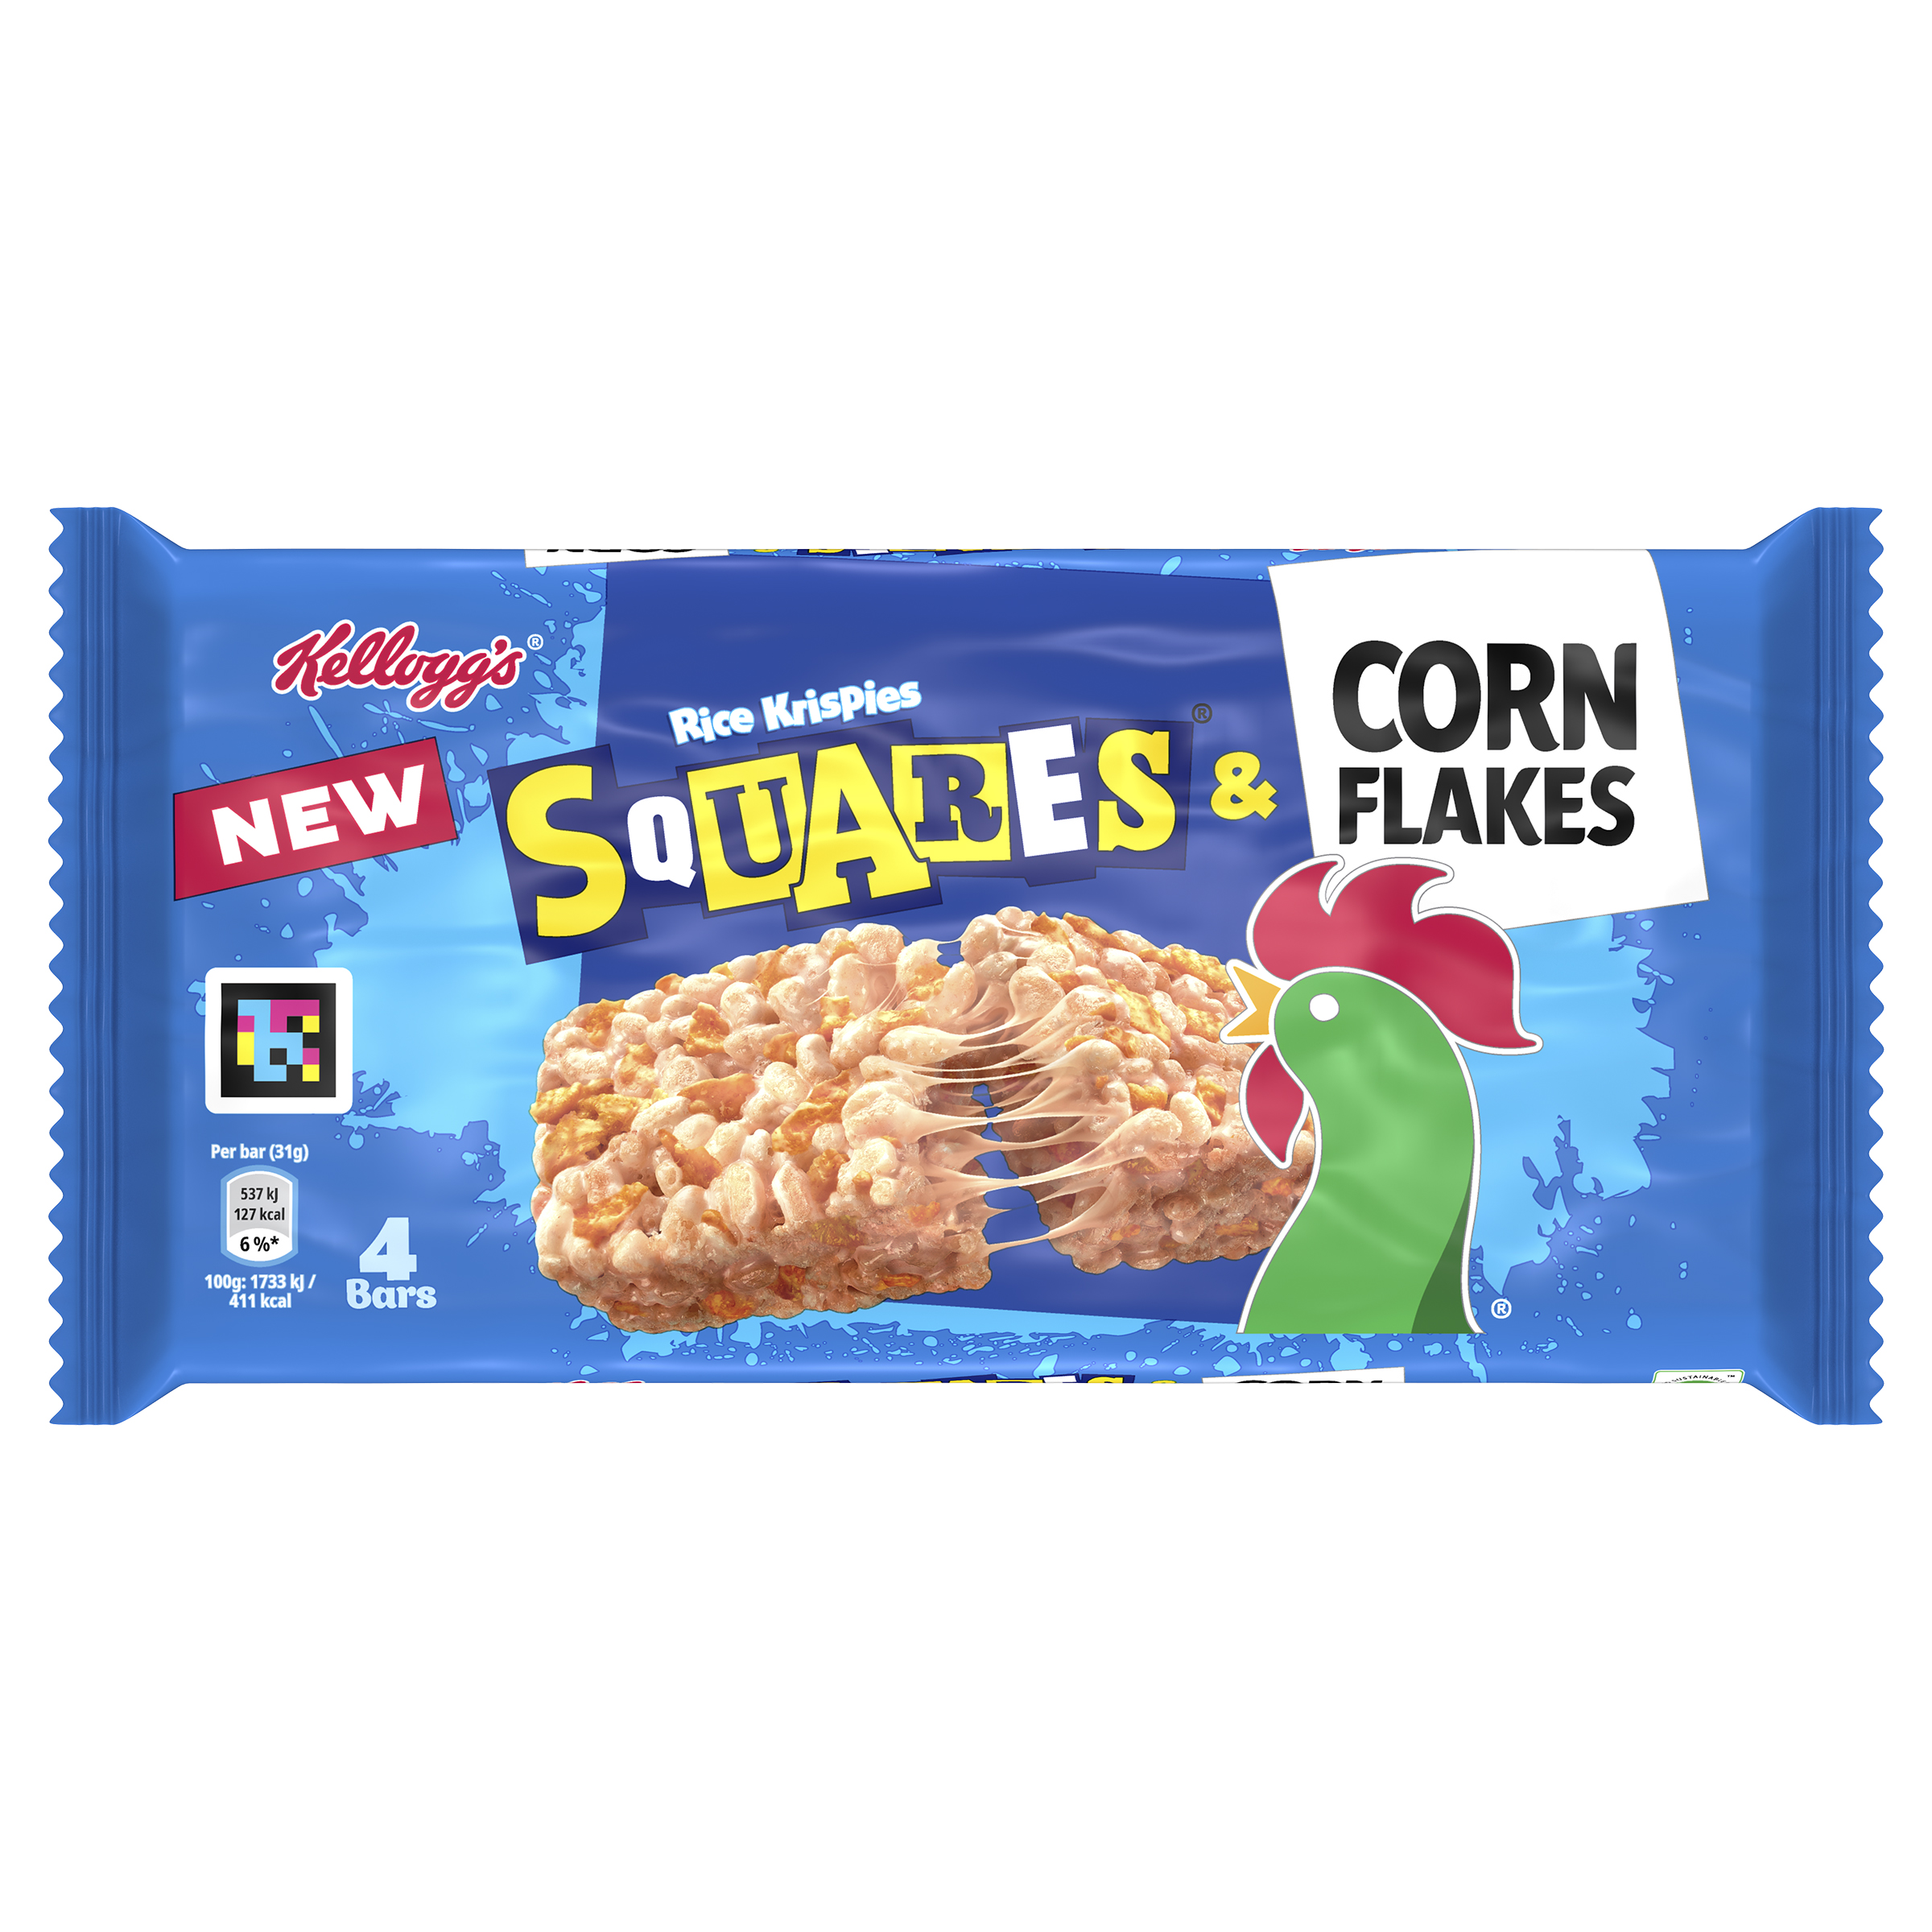

Images available to download here: [TH TO ADD FLIKR LINK]

1st July 2024: Kellogg’s has united two of its icons – Rice Krispies Squares and Corn Flakes – in what is sure to be the snack of the summer. A delightful twist on a classic favourite, Kellogg’s Rice Krispies and Corn Flakes Squares will be available from 3rd July in Morrisons.
This exciting new treat fuses the light, crispiness and chewy marshmallow of Rice Krispies Squares with the satisfying crunch of Corn Flakes, with taste testers saying they enjoy the ‘crunchy yet chewy texture’ and that the combination of the two offers ‘an extra dimension to the crunchiness’.
Available in Morrison’s from 3rd July, with other supermarkets to follow, the new Kellogg’s Rice Krispies and Corn Flakes Squares offer a deliciously unique taste experience that combines two beloved cereals in one yummy snack.
Whether you're looking for a quick bite on the go or a tasty treat to enjoy at home, this new multi-sensory flavour sensation is set to become a fan favourite.
Sam Harper, Brand Activation Lead - Snacks at Kellanova, said: “Corn Flakes have always been a much loved and celebrated part of Kellogg’s history. To be able to combine such a classic cereal product with the UK’s leading treat segment snack brand is extremely exciting. We worked really closely with customers to ensure the ratio of chewy Rice Krispies Squares to crunchy Corn Flakes was spot on and we can’t wait for more people to try it.”
The new Kellogg’s Rice Krispies and Corn Flakes Squares join the line-up of other popular flavours, including Rice Krispies Squares Delightfully Chocolatey, Rice Krispies Squares Caramel and Chocolate and Rice Krispies Squares Cookies and Cream flavour.

Kellogg’s Rice Krispies and Corn Flakes Squares

Single pack
RRP: 75P
Four Pack
RRP: £2.25
Eight Pack
RRP: £3

Available in supermarkets including:
Morrisons and select discounters from the 3rd of July
ASDA from w/c 14th July
Tesco from w/c 21st July
Sainsbury’s from w/c 19th August

- ENDS –
Notes to Editor
For further information on the Kellogg’s Rice Krispies Squares range visit www.kelloggs.co.uk

