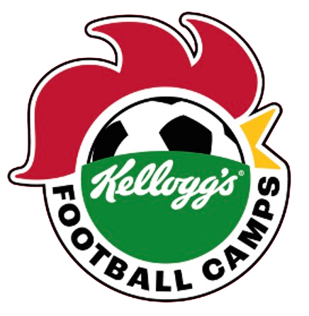**KEEPING** **TIGHT-KNIT ON THE PITCH!**

**WORLD’S LONGEST MULTI-CLUB SCARF LAUNCHES**

**KELLOGG’S FOOTBALL CAMPS, KICKING OFF NATIONWIDE THIS SUMMER**

* *Kellogg’s launches UK-wide football camp series for 5-15 year olds this summer with the EFL, Premier League champions Manchester City and Scottish powerhouses Rangers and Celtic.*
* *With crests from over 70 professional football clubs in England, Wales, and Scotland, the 100-metre scarf reflects the nationwide scale of the programme, with 70+ camps located across Great Britain to get kids on the pitch. 30,000 free spaces are available and parents can sign up at* [*www.kelloggsfc.com*](http://www.kelloggsfc.com)*.*
* *Past and present footballing icons including Michael Dawson, Jermaine Beckford, and Chloe Kelly supported the launch this week, as it’s revealed nearly 9 in 10 UK parents want to reduce their children’s screen time during the school holidays[1].*

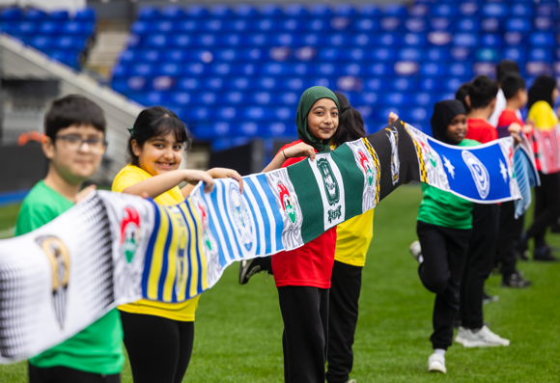

**MANCHESTER, 9 APRIL 2024:** The world’s longest multi-club football scarf, featuring more than 70 football clubs across England, Wales, and Scotland, has today been revealed to mark the launch of the **Kellogg’s Football Camps** programme.

In partnership with the English Football League, Manchester City, Celtic and Rangers, the football camps for girls and boys aged 5-15yrs will reach from Grimsby to Glasgow, Plymouth to Peterborough, supporting parents in keeping their kids active and entertained across the nation during the school summer holidays.

To celebrate the announcement, Kellogg’s is giving away 30,000 free places for the camps before they kick off this summer.

The news comes as new research shows that six in ten (59%) UK parents struggle to entertain their children throughout the school summer holidays. More than 8 in 10 parents (86%) want their child to experience less screen time during the break and the same percentage believe that team sport is hugely important to learn valuable life skills.

The 100-metre-long scarf represents the involvement of EFL clubs, plus Scottish powerhouses Celtic and Rangers. The impressive scarf is the result of more than 500 combined hours spent across design, knitting, and sewing with each club element hand-sewn by a team of specialists in Manchester.

Ex-pros came together at Birmingham City’s stadium, St. Andrews @ Knighthead Park, with EFL legends of the game including Jermaine Beckford and Michael Dawson, as well as children from local schools taking to the pitch to celebrate the launch.

To further show their support for the launch of the camps, Manchester City Women’s stars Chloe Kelly, Demi Stokes, and Ruby Mace surprised a group of young players as they trained at City’s Etihad Campus.

**Chris Silcock, Managing Director of Kellanova (the company that owns Kellogg’s) said:** *“Most families will be within 15 miles of a Kellogg’s Football Camp, giving children up and down Britain an opportunity to get active this summer. Run by FA qualified coaches, the camps aim to be fun and to give girls and boys the opportunity to get onto the pitch and follow in the footsteps of their footballing heroes.”*

**Speaking on behalf of the EFL’s involvement in the programme, former Hull City and England defender, Michael Dawson said:** *"For me, football camps during school breaks were where I had the most fun, kicking the football around with your mates. The EFL has such an advantage being part of so many different communities up and down the country, and to have Kellogg’s on board this summer to give so many kids the same opportunity I had when I was younger is* *really exciting.”*

Kellogg’s Football Camps sessions will take place throughout June/July* – September. Parents can sign their kids up at [www.kelloggsfc.com](http://www.kelloggsfc.com).**

**ENDS**

*\*June in Scotland, July across the rest of the UK.**\*\*18+. GB only. 2,500 camp places released weekly during 01/04/24 – 24/06/24. Purchase promo pack by 24/06/24 and claim by 16/08/24. Kellogg’s Football Camps session times and dates vary club to club. Visit kelloggsfc.com to claim camp space. Max 2 claims per household. Retain receipt. For further T&Cs, see promo packs and visit* [*www.kelloggsfc.com*](http://www.kelloggsfc.com)*. Detail on accessibility to the EFL-led camps:* [*https://www.efltrust.com/3d-flip-book/22126/*](https://www.efltrust.com/3d-flip-book/22126/)*.*

For all media enquiries, contact [kelloggs@wcommunications.co.uk](mailto:Kelloggs@wcommunications.co.uk)

1. *86% of British parents would like their child to experience less screen time over the school summer holidays, and to take part in more outdoor activities during this time. Research conducted early February 2024 by 72Point. 2,000 gen pop (parents of 7-11yr olds in England, Scotland and Wales).*