**GRATE news! America’s favourite snack makes its cheezy UK debut**

*Cheez-It packs a cheezy punch with the launch of three must-have flavours in new ‘Snap’d’ format*

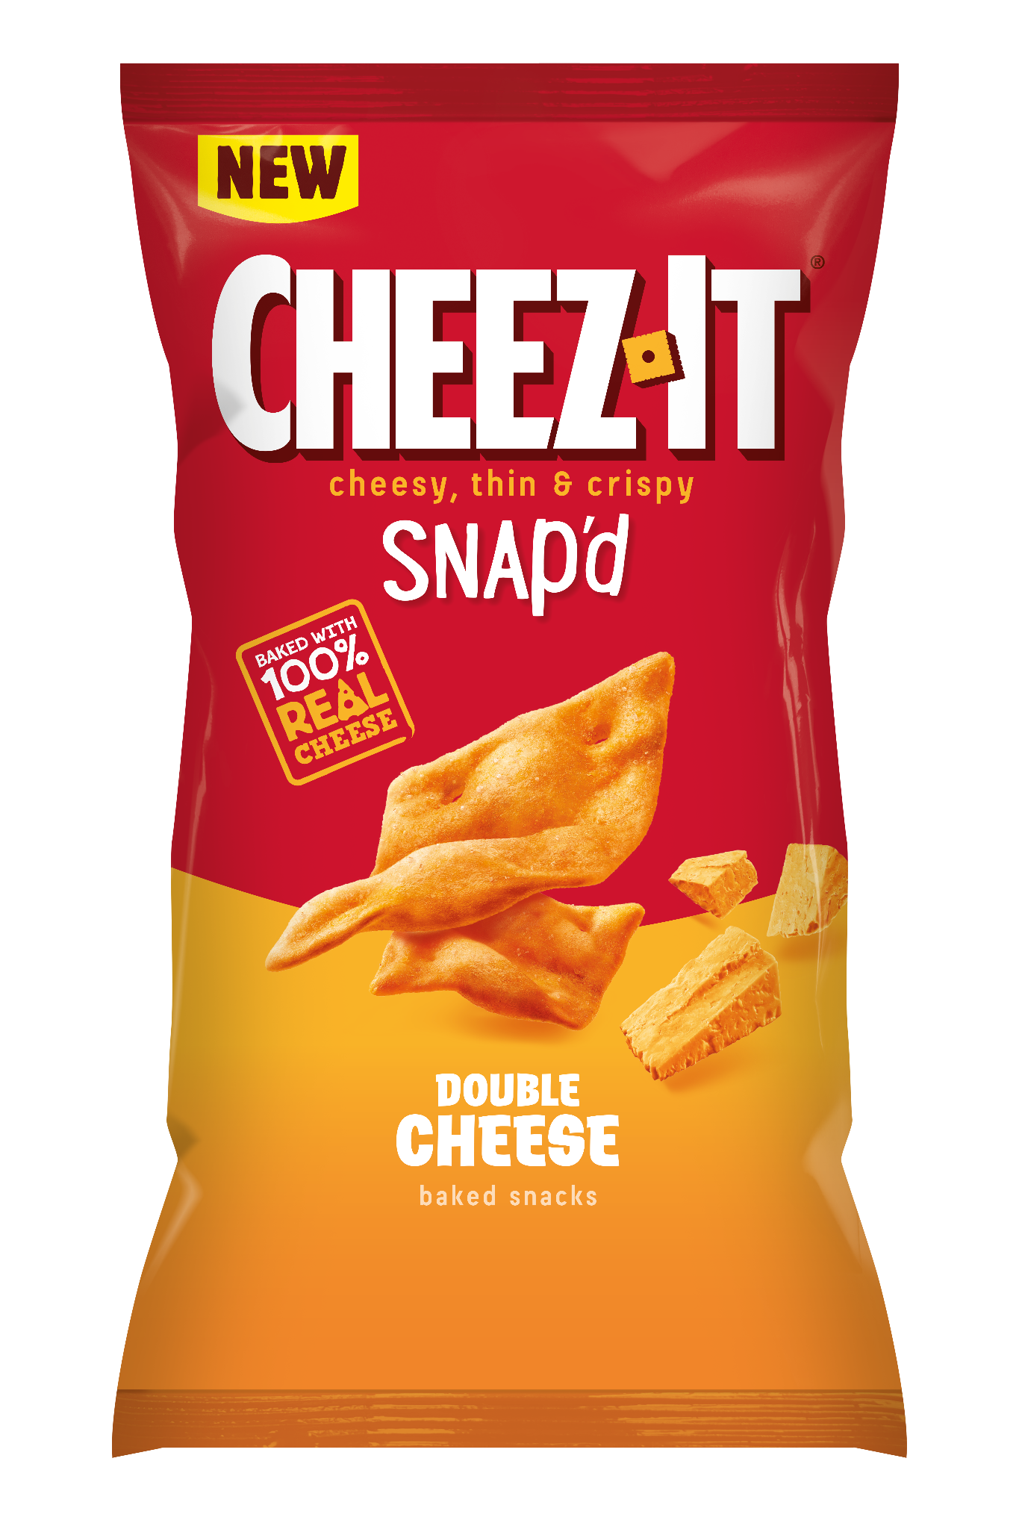

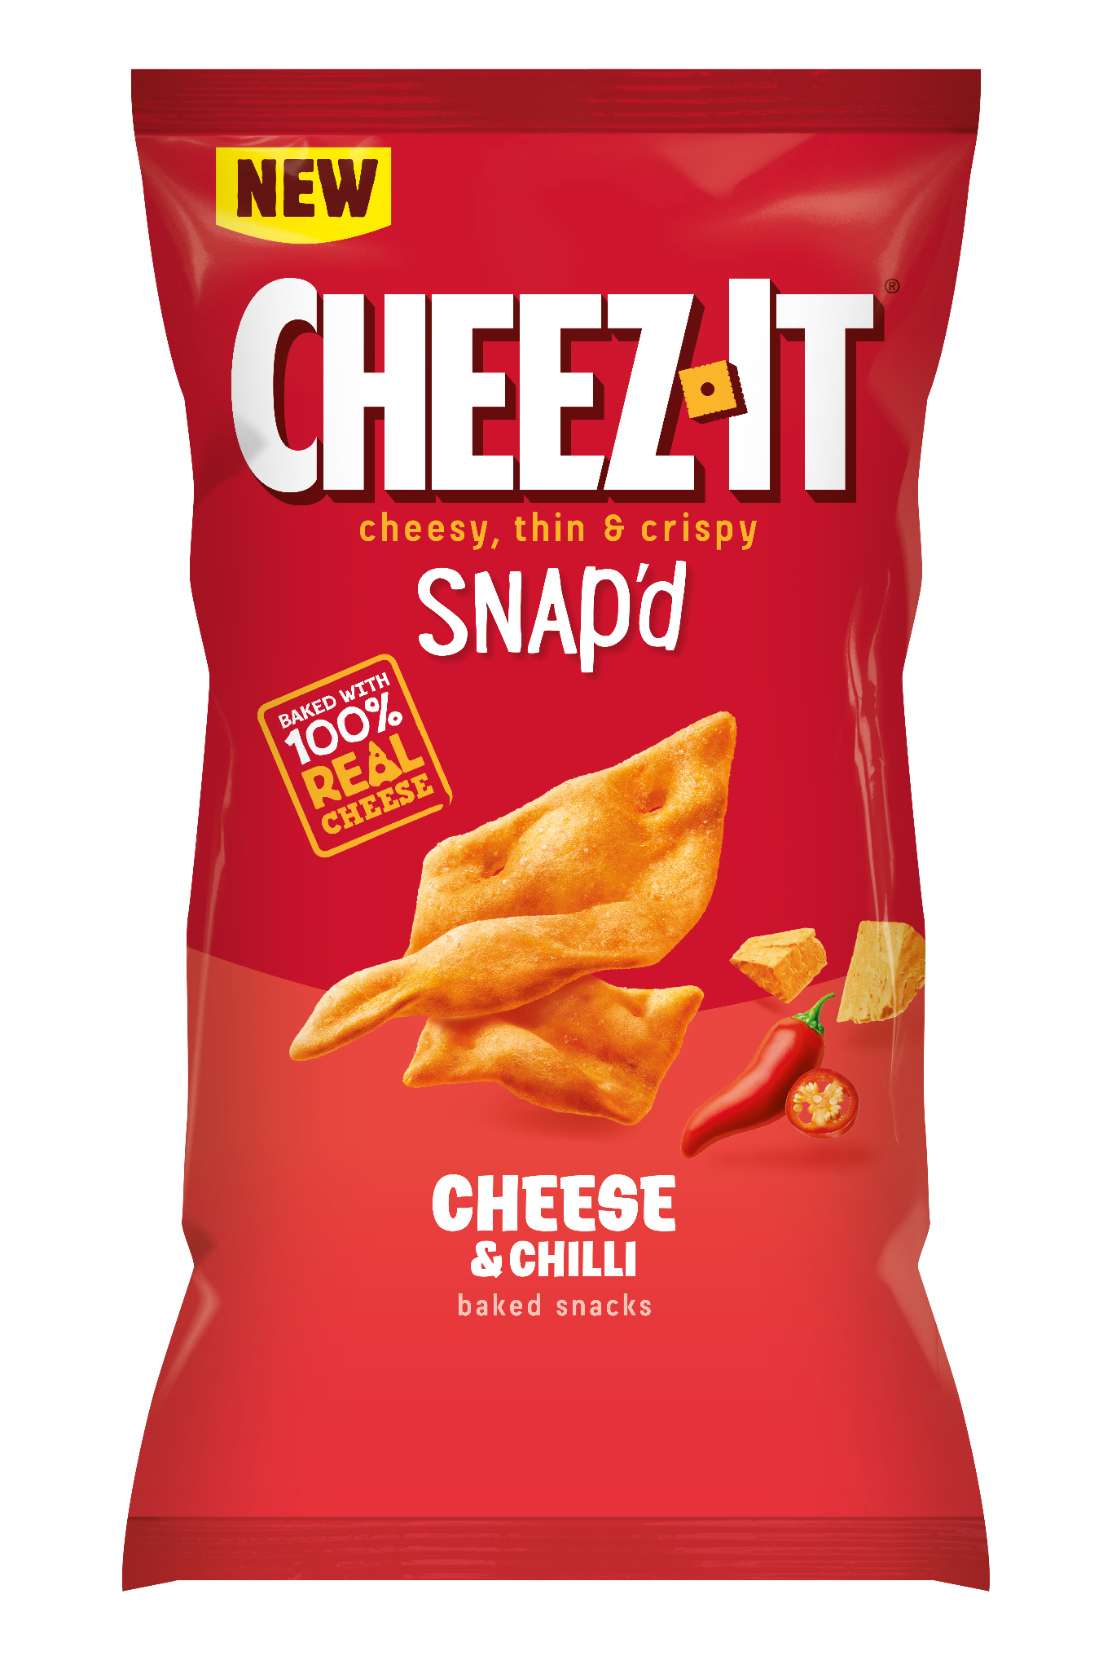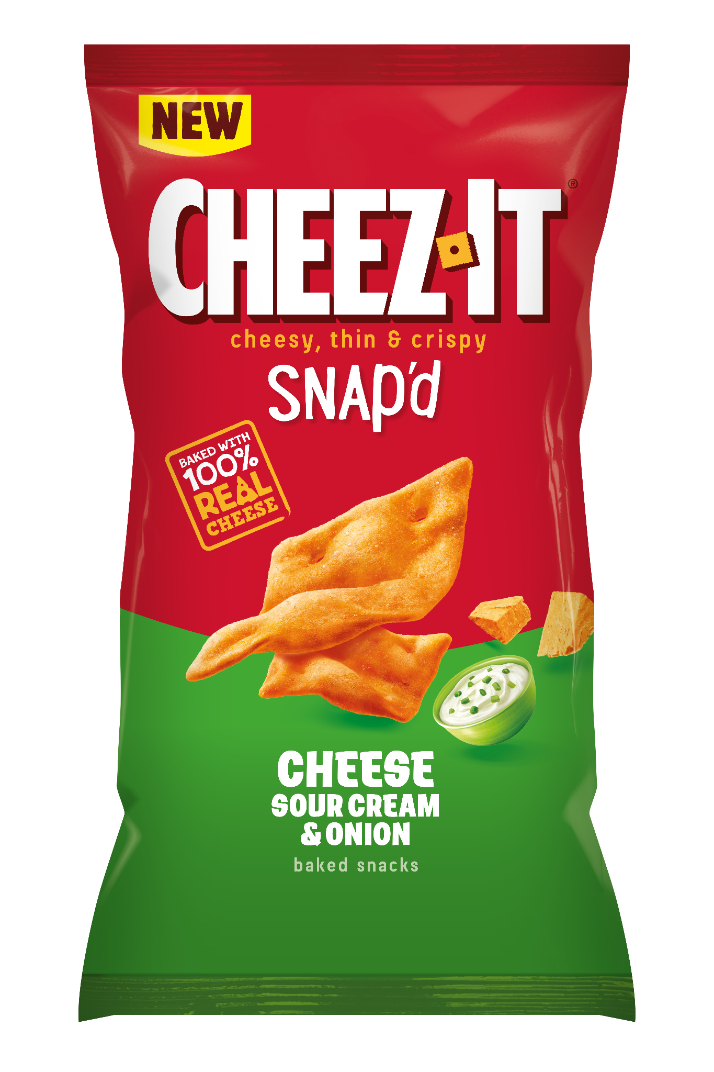

Cheese lovers might want to take a seat for this one... Due to popular demand, the iconic American favourite - Cheez-It - has finally crossed the pond, bringing the perfectly thin and crispy and totally cheesy snack to the UK.

Guaranteed to hit the spot, they are baked with 100% real cheese while its unique curved shape gives it the ultimate satisfying crunch. And as it’s baked, not fried, the flavour packs a powerful punch. Launching on to the UK scene are Cheez-It Snap’d in three flavours, Double Cheese, Cheese & Chilli, and Cheese, Sour Cream & Onion, these drool-worthy snacks deliver a party for your palate with every crunch.

Available nationwide from early August 2024, Brits can finally get a bite of the action and revolutionise their snack game. Perfect for parties, as an afternoon pick-me-up, or as a savoury treat, the ultimate Cheez-Hit has entered the chat.

The three flavours that are set to fill every snack lover’s desires include:

* **Double Cheese**: Packed with twice the cheesy punch, it's the perfect snack for those looking for a super cheesy delight
* **Cheese & Chilli**: A bold blend of cheesy flavour with a spicy kick, ideal for those looking to turn up the heat
* **Cheese, Sour Cream & Onion**: A harmonious mix of tangy and savoury notes that will keep you coming back for more.

A spokesperson at Cheez-It shared their excitement, saying: *“We’re absolutely thrilled to bring Cheez-It to this side of the Atlantic! We know the UK’s a nation of cheese lovers, and as this snack is baked with 100% real cheese, the only thing people won’t love is that it didn’t come to the UK sooner!”*

Cheez-It Snap'd is available from all major UK stockists.

**Product Information**

**Product :** Cheez-It Snap’d

**Flavours:** Double Cheese, Cheese & Chilli and Cheese, Sour Cream & Onion

**Available from:** August

**Pack size:**

Double Cheese: 40g, 65g, 120g, 150g and multipacks

Cheese & Chilli and Cheese: 40g, 65g, 120g, 150g and multipacks

Sour Cream & Onion: 150g and multipacks

**RRP*:**

* 150g: £2.00
* 120g: £1.85
* 65g: £1.25
* 40g: £1.00

*\*Retailers are free to set their own prices and is at their sole discretion*

**ENDS**