A third of Brits work during breakfast with “Zoom and Cereal” sessions commonplace

- WFH surge sees a third combine Zoom meetings with a morning meal
- Four in ten grab breakfast on the go during their morning commute
- Three quarters multi-task during breakfast, either with work, emails, scrolling social media feeds or sorting the kids out for school
- The Great British Breakfast Audit from Kellogg’s, commissioned to mark a bold new campaign featuring its iconic mascot, Cornelius the cockerel, shines a spotlight on nation’s unique morning routines

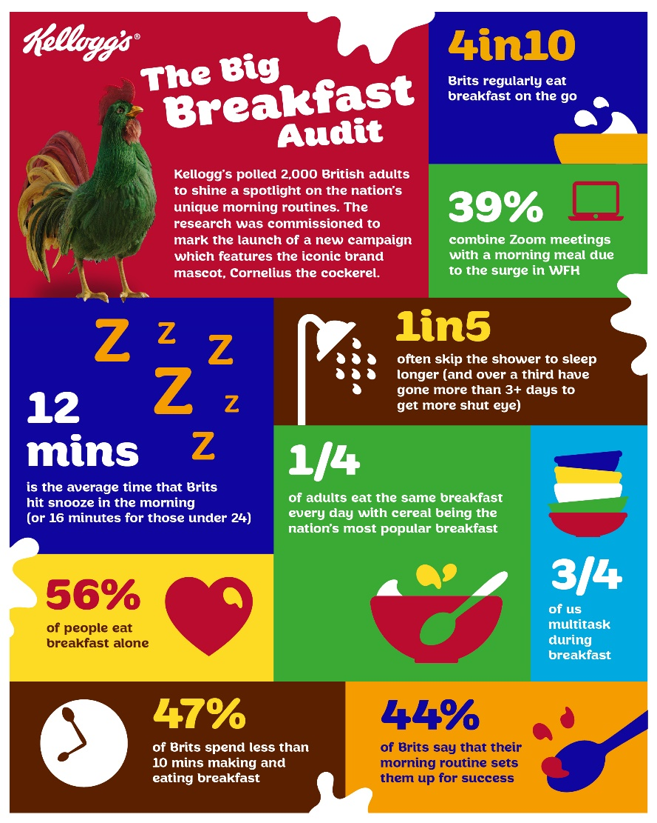
Changing morning routines have reshaped our breakfast habits, with a third (32%) now working during breakfast, combining meals with meetings or "Zoom and cereal" sessions.

Some consider breakfast to be the 'most important meal of the day', fuelling the body and a chance for families to sit down together. But the traditional leisurely family breakfast is becoming a thing of the past, a new study has found.

The research comes from Kellogg’s, which polled 2,000 British adults for its ‘Great British Breakfast Audit’, commissioned to mark the launch of a new campaign featuring its iconic mascot, Cornelius the cockerel. The results shine a fascinating spotlight on the nation’s evolving breakfast routines and how we do mornings in our own unique ways.

Over half of the respondents (56%) eat breakfast alone, while 48% devote less than ten minutes to making and eating their morning meal. This shift can be attributed to changing work patterns over recent years, with 45% who eat alone saying their family have a staggered start.

Four in ten grab breakfast on the go, during their morning commute, while one in eight (12%) admit that they skip breakfast altogether. Gen Z** eat breakfast on the go the most - three times a week on average.

Three quarters (76%) multi-task during breakfast, either with work, emails, scrolling social media feeds or sorting the kids out for school.

Sleep vs. showers

Despite the new trend for waking up between 5-9am for ‘me time’ before the 9-5 workday, exactly half of the respondents’ breakfasts are delayed by hitting the snooze button for a longer lie-in. A sleepy 28% press 'snooze' twice or more, with the average snooze time being 12 minutes each morning.

This rises to 60% of those aged 18 to 24, as younger adults are even more likely to struggle waking up.

Across the UK, a third (32%) skip going to the gym or making the bed (31%), and one in five (19%) of us would prefer to have an extra few minutes’ sleep than have a shower. And not just that, over a third (35%) of the population have gone for over 3 days without a shower in order to get that little bit of extra shut eye.

Popular breakfasts

The most consistent aspect of British breakfast culture was cited as the food we choose to eat with many reaching for the tried and trusted. An overwhelming 68% of British adults report eating the same meal at least four times a week, with a quarter (24%) eating the same breakfast every single day.

Cereal is the most common choice, cited by 38%, while 18% take toast and just 7% regularly have a full English breakfast.

Northerners are more likely to take tea at breakfast while Southerners prefer coffee.

Starting the day in the right way

The research found that half (48%) of us identify as a “morning person,” with men (51%) more likely than women (44%) to call themselves early risers. London (58%), interestingly, has the highest percentage of self-proclaimed ‘morning people’.

Across the nation, 44 per cent agree that their morning routine sets them up for success. The study found that watching breakfast TV (29%), listening to the radio (25%) and being in a quiet space without media (16%) are the favoured ways that people set themselves up for a good day. Over one in ten Gen Z-ers** (13%) favour meditation.

A quarter (25%) avoid social media in the morning due to its potential to negatively affect their mood and stress levels, and one in five (21%) actively avoid the news because it’s too bleak. Lack of time was cited as the main source of morning stress (17%), followed by personal worries (13%) and family responsibilities (11%).

When it comes to chat at the breakfast table, the British obsession with the weather remains as strong as ever. 23 per cent of respondents admitted that the weather is their most frequent breakfast opener, followed by discussions about current events (19%) and homework (9%).

But 36% admit they never speak to anyone at breakfast and for 24% the morning meal affords a 'quiet space' free from digital devices.

Emily Dutton, Brand Activation Manager at Kellogg’s said: “These findings show just how unique our mornings are. Our Great British Breakfast Audit reveals that while some of us prefer quick and on-the-go, others rely on breakfast as peaceful ‘me’ time.

Kellogg’s has been waking people up since 1906 - we ‘get’ mornings. It’s never been clearer that we all need ‘you do you’ time to start the day off right, and our audit shows that our morning habits are just as diverse as our breakfast choices.”

Cornelius the cockerel, Kellogg’s beloved mascot since 1958, has recently been reimagined in 3D for the first time in a new campaign ‘See you in the morning’ which celebrates the unique ways everyone approaches mornings.

ENDS

Notes to editors:

For more information, press interviews, or additional data insights, please contact: calli.holden@taylorherring.com
The survey of 2,000 British adults was conducted by OnePoll in November-December 2024 on behalf of Kellogg’s.

*The ten cities in the UK that snooze for the longest each day:
- Swansea (22 minutes)
- Worcester (19 minutes)
- Portsmouth (17 minutes)
- Plymouth (16 minutes)
- Wrexham (16 minutes)
- Coventry (15 minutes)
- Sheffield (15 minutes)
- Gloucester (14 minutes)
- Cardiff (14 minutes)
- Aberdeen (14 minutes)

**Gen-Z classified as 18-24 year olds for the purposes of this research

